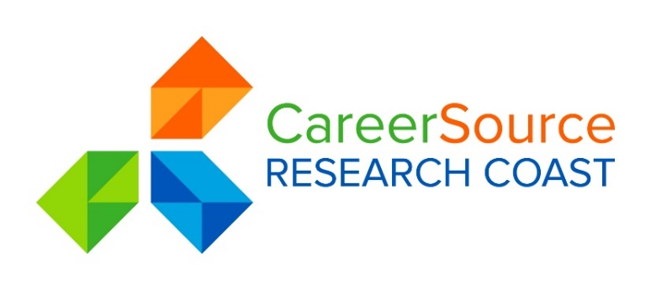
PROGRAMS & SERVICES COMMITTEE AGENDA

Date: Wednesday, April 4, 2018
Time: 8:00 A.M.
Place: CareerSource Research Coast
584 NW University Blvd., Suite 100
Port St. Lucie, Florida 34986
866-482-4473
https://www3.gotomeeting.com/join/270365422
Dial 1 877 568 4106
Access Code: 270-365-422

 | 1. | Welcome & Attendance
 | 2.
 | 3.
4.

5.
INFORMATION/DISCUSSION ONLY
 | 6.
 | 7. | Set Agenda Items for Next Meeting – June 6, 2018
 | 8. | Adjournment

** Indicates possible voting item and open for public comment

