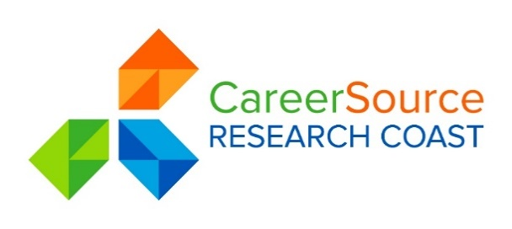
YOUTH COUNCIL AGENDA

Date: Tuesday, April 3, 2018
Time: 8:00 A.M.
Place: CareerSource Research Coast
584 NW University Blvd., Suite 100
Port St. Lucie, Florida 34986
772-335-3030
https://www3.gotomeeting.com/join/388212486
Dial 1 877 309 2070
Access Code: 388-212-486
 | 1. | Welcome, Attendance & Pledge of Allegiance
2.

3.

4.

5.
INFORMATION ONLY
 | 6.
 | 7. | Set Agenda Items for next Youth Council Meeting – June 5, 2018
 | 8. | Adjournment

** Indicates voting item and open for public comment

